Vocabulary Study Guides
For each unit, you will make a study guide. There are three types of study guides we will use. Each type will be discussed and demonstrated in class.

- Word study guide – you will write the vocabulary word, part of speech, definition, synonyms, and antonyms.
- Picture study guide – you will write the word, draw a picture associated with the word, and create a sentence about the picture using the vocabulary word. Example:
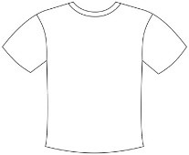
Apparel I packed my apparel, including my favorite shirt.
- Ladder study guide – you will write the word, then write a word it reminds you of, and continue until you get to the definition. Get creative.
Example: besiege bees bees sting or attack
So…besiege means to attack by surrounding with military force.
This assignment will be given at the introduction of each lesson and is due the day prior to the test.

